Large File Storage

What is Large File Storage?
# Source: AI Source: Provided by: [Data Path: Persons Table -> ID Column: 1, Name_En Column: Motasem Essam] -> From: [ChatGPT] on [2/15/2026]
In Git, LFS (Large File Storage) is a system designed to handle large files efficiently, because Git itself doesn’t manage big files well. Without LFS, storing large files like videos, datasets, or high-res images in a Git repo can slow down performance and bloat the repository.

What Git LFS Does
# Source: AI Source: Provided by: [Data Path: Persons Table -> ID Column: 1, Name_En Column: Motasem Essam] -> From: [ChatGPT] on [2/15/2026]
- Replaces large files in your repo with lightweight pointers.
- Stores the actual file contents on a separate server (remote LFS storage).
- When you clone or pull, Git LFS downloads only the files you need, instead of the entire history of large files.

How It Works
# Source: AI Source: Provided by: [Data Path: Persons Table -> ID Column: 1, Name_En Column: Motasem Essam] -> From: [ChatGPT] on [2/15/2026]

- You track files with LFS:
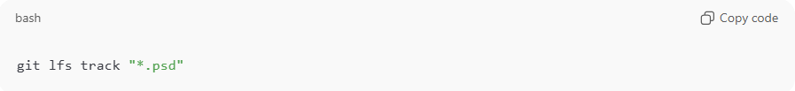
git lfs track "*.psd"
This tells Git to handle all Photoshop .psd files with LFS.
It creates a .gitattributes file to keep track of this.
- When you commit a tracked file, Git stores a small pointer file instead of the full file.
- The actual file is stored on the Git LFS server (usually the same as your Git hosting service if it supports LFS).
- On checkout or pull, Git LFS fetches the real file automatically.

Benefits
# Source: AI Source: Provided by: [Data Path: Persons Table -> ID Column: 1, Name_En Column: Motasem Essam] -> From: [ChatGPT] on [2/15/2026]
- Faster clones & pulls because the full history of large files isn’t downloaded immediately.
- Keeps your repository lightweight.
- Works well with teams and CI/CD pipelines that need to manage large media or datasets.

Common Commands
# Source: AI Source: Provided by: [Data Path: Persons Table -> ID Column: 1, Name_En Column: Motasem Essam] -> From: [ChatGPT] on [2/15/2026]
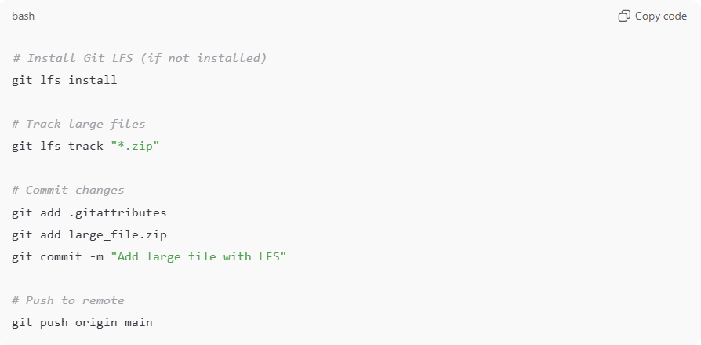
# Install Git LFS (if not installed)
git lfs install

# Track large files
git lfs track "*.zip"

# Commit changes
git add .gitattributes
git add large_file.zip
git commit -m "Add large file with LFS"

# Push to remote
git push origin main

💡 Example use cases:
# Source: AI Source: Provided by: [Data Path: Persons Table -> ID Column: 1, Name_En Column: Motasem Essam] -> From: [ChatGPT] on [2/15/2026]
- Game assets (textures, models)
- Video editing projects
- Machine learning datasets
- Audio files in music production

